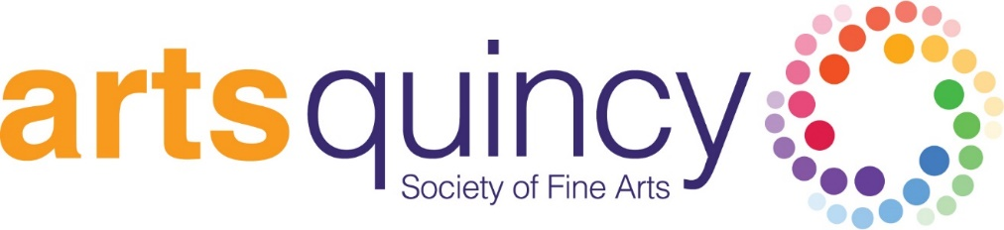

Bulk Mailing Services
Here are the instructions on using the bulk mail.
1. Local Printers may use our permit on your behalf as an Arts Quincy Partner Organization.
2. You must have a minimum of 200 good addresses to use bulk mail.
3. You MUST call Arts Quincy to let us know that you’ll be using the permit at least two weeks before your mailing. The billing for your postage will still come through this office. Arts Quincy pays the postage in advance for any mailings that go out using our permit number.
4. As always, your pieces must be 100% identical to use a bulk mail permit.
5. You will receive 2 bills: Your printer will charge you for your printing plus the bulk services (4 to 5 cents per piece. *Please note that your printer may not itemize the bulk services charge and printing separately. Sometimes this is rolled into one per-piece figure.) Arts Quincy will send you an invoice for your postage cost only with no additional fees.
6. Please remember that when you send Bulk Mail, the Post Office treats your mailing differently. We generally see bulk mail get to homes fairly efficiently, but the Post Office is allowed to wait up to 3 weeks to deliver your piece. Please plan accordingly if you have time-sensitive materials that you’re sending, particularly around big mail holidays like Valentine's Day, Mother's Day and Christmas.
7. You will experience substantial savings by using a Nonprofit Bulk Mail rate!

# # #
Please call the office for more information or any questions at 217-222-3432 or email office@artsquincy.org.

